Circulation Statistics Reports
The link below will get you to Web Management Reports - the spreadsheet version that opens directly into Excel.
http://sierra-app.wrlsweb.org/iii/webrpt/app

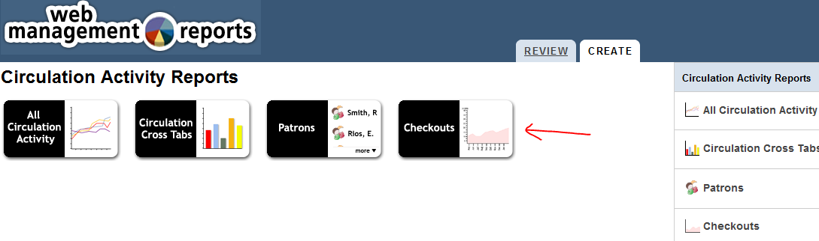

Click on Checkouts

A login in window pops up.
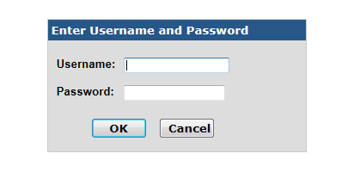
Type in your username and password. ClickOK.

The Settings window opens.

Click on the dropdown for Dates and choose Last Month (to get a monthly report).

Click on the dropdown for Locations and choose One Only (to get the stats for your library only).
This opens a dropdown list of all the libraries. Click on your library.

Click on the dropdown for Report by. Choose the type of report you wish to run.
Ptype is the circulations by the Patron type.
Itype is the circulations by the Item Material type.
Location is the circulations by the Collection Locations in your library.
PCODE4 is the circulations by Municipalities.

After choosing your settings, click on the Submit button.

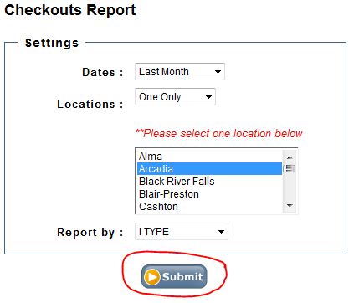

The report should take about a minute to run. When it is finished a pop up will appear at the bottom of your screen asking if you wish to open or save the report.

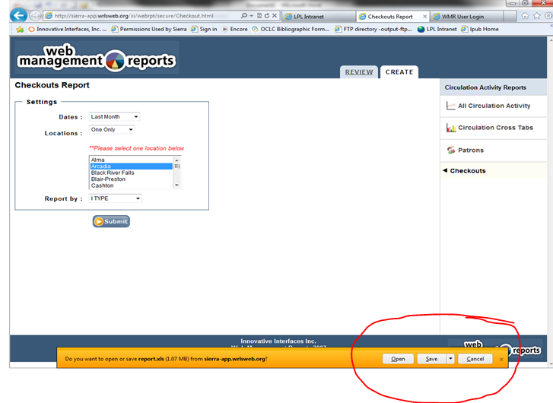

Open the report and Save it to your computer.

After running and/or saving reports, go to the Review tab and delete your report(s).

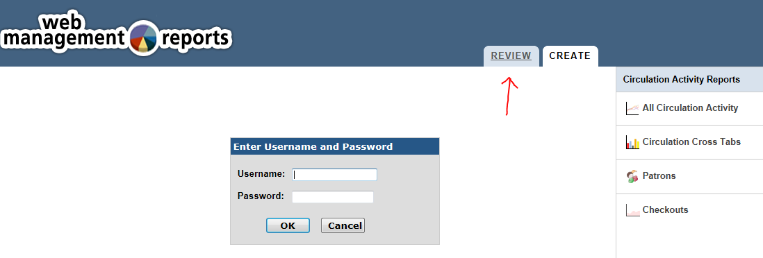

After you type in your username and password, a list of all the reports comes up.
Click in the box to mark you reports for deletion.

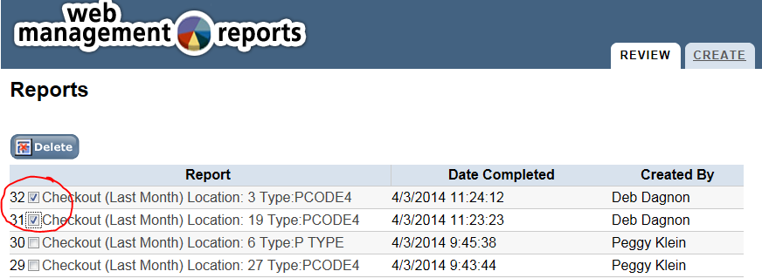

Then click the Delete button to delete the selected reports.
A window pops up asking if you are sure you want to delete. Click OK.

