The Internet for Beginners

What is the Internet?
The Internet is a global system that allows computers to talk to one another. The idea of the Internet started in the 1960s when the United States government began researching a way to communicate using computers. In the 1980s, improvements in technology and better funding led to the start of the Internet that we use today. It was mostly used by scientists and academics until it was commercialized in the 1990s.

Websites aren’t the only thing on the internet. You can also game, chat, and transfer files. All of these websites and places to game and chat live on computers called servers. These have web addresses, or IPs, which are a string of numbers. They typically have domain names too, which make it easier for us to remember them (like google.com or yahoo.com).

You can connect to the Internet through a physical wire plugged into your device or through a wireless signal.

Web browsers
Web browsers are software that let you view webpages. Common ones are:
Firefox Internet Explorer Chrome
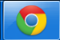
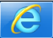
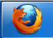

Each browser will have minor differences, but they generally have:

A back button (to go back to the previous webpage you viewed) A place to enter a URL (see below) Tabs (open windows)

A homepage button A way to bookmark a page A way to set your preferences

Your homepage is the first page that appears when you open your browser. Bookmarks are sometimes called favorites; these are websites you wish to visit frequently or have easy access to in the future. You can set your own preferences (sometimes called options or settings), like your homepage, your security, and which search engine to use.

Getting around
A URL (uniform resource locator) has three parts:
http://www.lacrosselibrary.org/computer-classes
how you want to get to a website the website’s domain name a path to a particular place on the website (such as the computer classes page at the La Crosse Public Library’s website)

Domain names can have different suffixes. Aside from .com (which stands for commercial), there’s:

.net (stands for network)
.gov (government websites)
.edu (educational websites)
.org (intended for nonprofit organizations)
.mil (military websites)
.us, .au, .de, .fr (different countries’ websites: US, Australia, Germany, France, etc)

Note: everything but .edu, .gov, and .mil can be used by anyone, so a website may not represent what’s implied by its suffix.

When looking at websites, you’ll notice a few things: there are ads (typically along the tops and sides of pages) and there are blue, underlined words. These are links to other webpages or websites. When you hover your mouse over them, your cursor turns to a little hand. This indicates you can click on the link.

In your browser’s URL (or address) bar, you can type in the URL for a specific webpage you would like to go to. Some address bars will let you just type in words that describe what you’re searching for, and will pull up the results from a search engine, like google.com.

Searching
In your address bar, or at a search engine’s website, type in a few words describing what you’d like to find. As you’re typing, many search engines will try to guess what you’re looking for. You can keep typing or choose from one of the options.

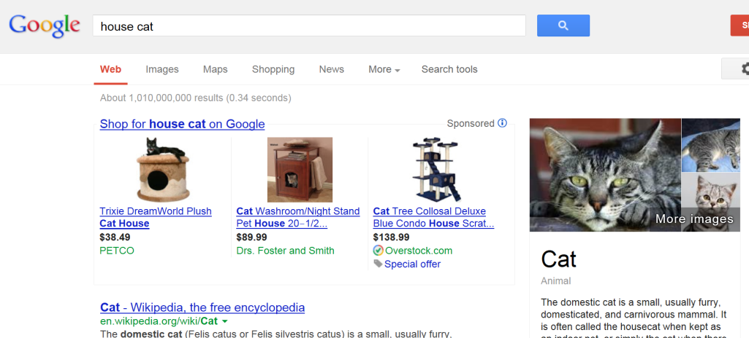
The search results include links to shop for related items, links to web sites, images, and more. News articles (if any are relevant) will often be at the top of the search results. Look through the results and click on links that interest you.

We are able to do keyword searching like this because search engines routinely index websites. No one wants to look through a million results, though, so search engines have complex algorithms that determine relevancy and ranking.

Popular email websites
aol.com
gmail.com
hotmail.com (also known as live.com and outlook.com)
yahoo.com

Popular entertainment websites
hulu.com (tv and movies; free and monthly subscription versions)
netflix.com (tv and movies; monthly subscription)
youtube.com (user-created videos; free)

Popular shopping websites
amazon.com
craigslist.org (local)
ebay.com (auctions)
etsy.com (handmade, vintage)

Popular social media websites
facebook.com
flickr.com
pinterest.com
twitter.com

Popular informational websites
about.com
anywho.com (look up phone numbers)
espn.com
imdb.com (Internet Movie Database)
kbb.com (Kelly Blue Book)
m-w.com (Merriam-Webster dictionary)
nlm.nih.gov/medlineplus (health)
snopes.com (find out if something’s a hoax)
weather.gov
webmd.com (health)
wikipedia.org (user-created encyclopedia)
yelp.com (business and restaurant reviews)

Popular job-hunting websites
craigslist.org
indeed.com
linkedin.com
monster.com

Find more great resources at our website:
www.lacrosselibrary.org
Internet slang
You can find lists of internet slang online. A few are:
IMHO: In My Humble Opinion
LOL: Laugh Out Loud
OMG: Oh My God
NSFW: Not Safe For Work (content not safe for viewing at work)
Blogs: Online journals
Emoticons: letters and numbers used to represent emotions or facial expressions, such as :) for smiling
Paywalls: a way to block people from accessing content unless they pay for a subscription
Trolls: People who behave maliciously on the internet

Safety
If you wouldn’t share a piece of information with a stranger on the street, don’t share it with a website unless you trust it! Do not share your credit card number, bank account number, social security number, address, or passwords unless you fully trust a website. Many people won’t share their real name or birth date, either. Trust a site? Before entering in your information, check to make sure their URL says HTTPS://, not just HTTP://.

If you receive an email from someone you don’t know, delete it. Don’t open email attachments from people you don’t know. Sometimes your friends’ emails will get hacked, though, and everyone in their contact list will get a spam email. If it’s from a friend but the subject line seems strange, don’t open it. Check with your friend first.

Don’t believe everything you see or read on the Internet. Confirm information using websites (or other sources of information, like books!) you trust.

Viruses and malware
A virus is malicious software that you accidentally download. If you have a virus, theoretically your computer can be made to do whatever the virus programmer wants. It is often destructive. Malware usually tries to trick you into entering your credit card information. You can install antivirus software to help protect your computer. There are free and for-pay versions.

Last updated 3/21/14

