CLEAR EXPIRED HOLDS AND HOLDSHELF
It’s important to be sure to clear expired holds from the database in order to maintain the integrity of holds. This is a process that should be run daily.

To access this feature, click on the Clear Expired Holds and Holdshelf from the Function menu.

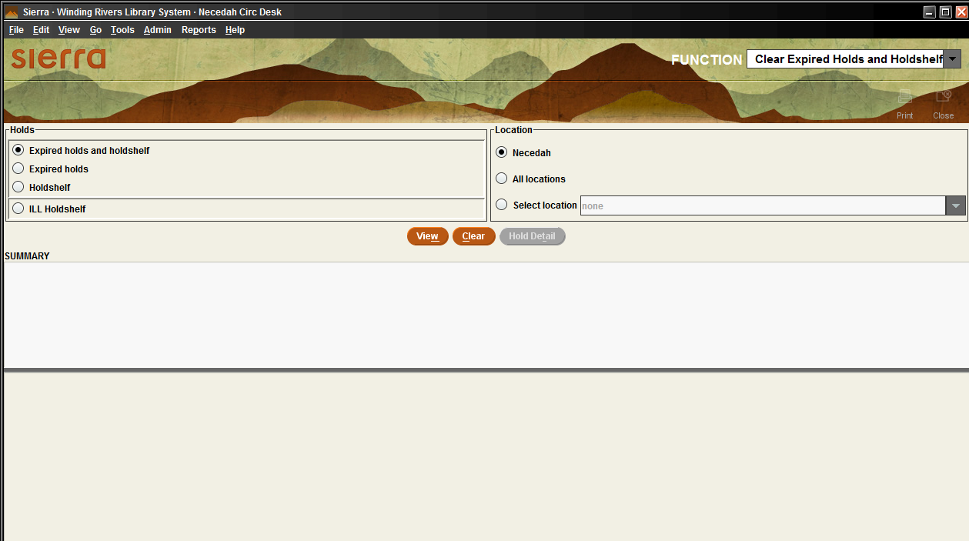
On this screen you’ll see 4 radio buttons on the left, denoting the different types of expired holds. In the right column, the radio button should be defaulted to your library. Leave the defaults as they are. It’s important to clear all holds, but only at your library.
The four buttons for holds are broken down as follows:
- Expired holds and holdshelf – This is a combination of the next 2 categories.
- Expired holds – This indicates holds that have expired because their “Not wanted After” date has been reached. These are unfilled holds that have timed out.
- Holdshelf – This category is holds that have been filled, but the patron hasn’t picked them up by the pickup deadline. They should be on your hold shelf.
- ILL holdshelf – These are items processed in the Sierra ILL module that haven’t been picked up and therefore have expired. Since WRLSWEB is not using the ILL function in Sierra, this category can be ignored.

With the radio button by Expired holds and Holdshelf selected, click the View button. This will give you the total list of all holds that have expired. If you wish to print the list, you can do that now by clicking the Print icon in the upper right corner of the screen.
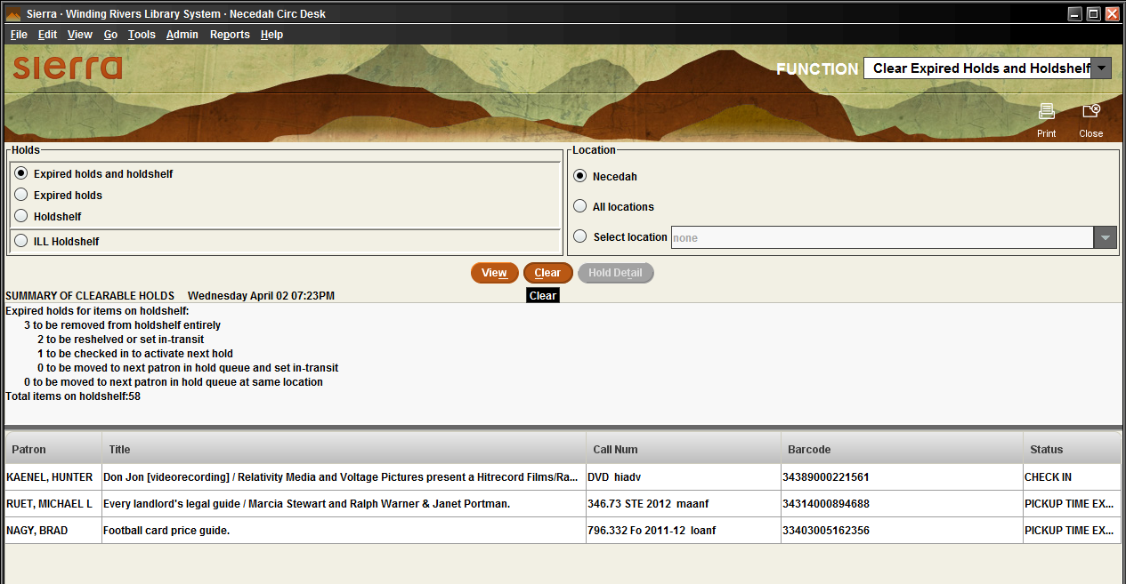
Go to the shelf and pull the items from the screen or printed list. When you have retrieved all the items, click the Clear button. The Clear button will be grayed out but the list will remain on the screen. If you click View it will clear the list from the screen. The list will also disappear if you exit the function and enter again.
Once the list is removed from the screen there is no further record of holds that need to be cleared. Be sure you’ve accounted for all items or printed the list before clearing the screen.
If you don’t clear the list before exiting the Clear Expired Holds and Holdshelf function you’ll get a warning message reminding you to clear it. You always want to clear the list. Failure to clear the list will mean those items will be routed back to your hold shelf on checkin.
You can now check the items in. Some will be put in transit to return to the owner or to fill the next hold. Some will be ready for shelving at your library. If your library is the pickup for the next hold, a hold slip will print.
Remember to do this task daily to help insure the smooth operation of the holds process.

