Doing ILL ‘On The Fly’ Records in Sierra
There are 2 ways to do ILL entries in Sierra:
- At Check Out(Circulation Desk) – This allows staff to enter the ILL and check it out to the patron at the same time.
- In Catalog – This allows staff to prepare the ILL for later checkout at the desk.
Either method or both can be used, depending on the circumstances or individual library preferences.

Preparing ILLs at the Circulation Desk
- Call up the patrons account
- Be sure the cursor is in the box labeled “Key or Scan Item or Patron Barcode”
- Type the letter ‘b’ (This tells the software the information that follows is a barcode).
- Scan the barcode from the ILL item you are checking out. An Item-on-fly screen will appear. Click the New button.

- Highlight ontheflyIL: ILL brief bib. Click Select.
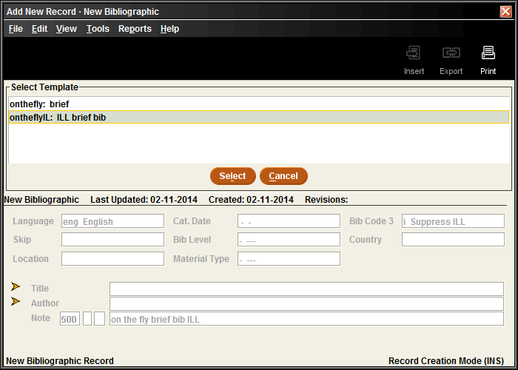
- The ILL on the fly template will load. The first field is title, which must be filled out. It’s a good idea to add ‘ILL’ after the title to clarify the item’s status. All caps is also a good idea. Click Next.
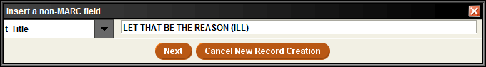
- Author is the next line. That can be filled in or skipped, according to your library’s preference
- Item Type is the next line. It’s very important that you enter type ‘100 ILL’ on this line. The ILL item type determines that your ILLs cannot be renewed by patrons, reserved, fined, etc.
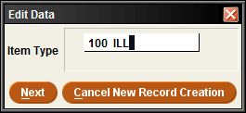
- Price should be set to a default amount for your library. $25 is a common default. It can always be adjusted later.
- Location can be set to any collection code, to the generic code for your library (such as al or wo), or be skipped.

- On the call number line you can enter the call number from the item. Or from the drop down menu choose Wiscat and enter the request number.
- The template is now finished. If you want to change the Message line from “Route to cataloging” to “Route to ILL, this is the time to do it.
- Click Save. The On the Fly message will appear. Click OK to remove it.
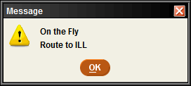
- Click the Change Due Date button to adjust the due date on the item, if needed.

- This ILL item is now checked out and may be given to the patron.

Preparing ILLs at the Catalog Function
- At the FUNCTION box select Catalog from the drop down menu. This will take you to a catalog search and default you to title search.
- From the drop down menu by title change the search to Barcode. Scan the barcode from the ILL item you wish to add. (NOTE: For this search it’s not necessary to add the ‘b’ in front of the barcode).

- Sierra will attempt to find the barcode you just entered in the database and take you to a browse screen that includes the closest match. From this screen, click the New button.
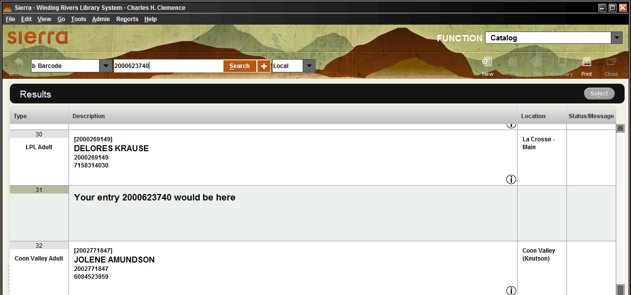

- Highlight ‘ontheflyIL: ILL brief bib.’ Then click Select.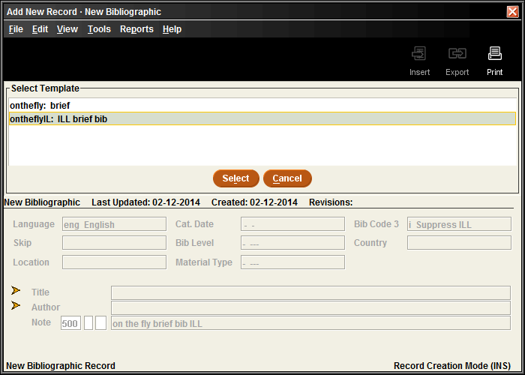

- The first field is title, which must be filled out. It’s a good idea to add ‘ILL’ after the title to clarify the item’s status. All caps is also a good idea. Click Next to go to the next line of the template.
- Author is the next line. That can be filled in or skipped, according to your library’s preference.
- At this point the bare bones of the bib are entered, so click Save. You now need to add an item to that bib record. To do that, change the search default from Barcode back to Title and do a search for the title you just entered.
- At the next screen, change the View from All to Item, then click the Attach New Item button.

- Item Type is the first line you’ll see. It’s very important that you enter type ‘100 ILL’ on this line. The ILL item type determines that your ILLs cannot be renewed by patrons, reserved, fined, etc.
- Price should be set to a default amount for your library. $25 is a common default. It can always be adjusted later.
- Location can be set to any collection code, to the generic code for your library (such as al or wo), or be skipped.
- On the barcode line, scan the barcode from the ILL item you are adding.
- On the call number line you can enter the call number from the item or from the drop down menu choose Wiscat and enter the request number.
- The template is now finished. If you want to change the Message line from “Route to cataloging” to “Route to ILL, this is the time to do it.

- Click Save. The record is now in the database, but not checked out.

- Complete the preparation of the item for checkout. Be sure to include a bookstrap or other paperwork with the item that indicates the due date which desk staff should use at checkout.

- When the patron comes in, call up the patron’s record and scan the item to check it out. (NOTE: for some items it may be necessary to precede the barcode with a ‘b’). The ‘On the fly’ message will appear. Click OK.

- Click the Change Due Date button to adjust the due date of the item to match the bookstrap or other due date slip, if necessary.

Checking in ILL ‘On the Fly’ items.
- ILLs may be checked in either at the Check Out (Circulation Desk) function or at Check-in (No Patron) function. When checking in an ILL it is necessary to put the letter ‘b’ in front on the scanned barcode to inform the system it is a barcode. Otherwise you’ll get an error message.
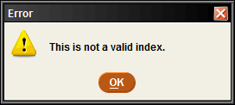

- In the ‘Key or Scan Item Barcode’ box, type a ‘b’, then scan the barcode. The item will check in and the ‘on the fly’ message box will appear. Click Yes to complete the checkin.
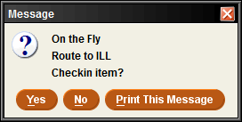
- Remember that whichever method you use to enter ILLs the bib records will remain in the database after checkin. The checkin action only removes the item from the patron’s account. These bibs will later be removed by another process.

