INSTALLING AND USING SIERRA OFFLINE CIRCULATION

Offline Circulation allows libraries to check out items to patrons when the library is unable to connect to Sierra. The Offline Circulation program must be downloaded and installed on each computer that will be used for checkout while Sierra unavailable. It must be in place before the library needs to use it.

If the entire network is down you will be contacted by phone and asked if you wish to use offline circ. If you do, you will be contacted again when the network is back up so files can be uploaded in an orderly fashion. If only your library needs to use offline circ, please contact someone at WRLSWEB to let them know (Charles or Deb or Alan). Then as soon as you’re back up, contact that person again. It’s important to upload the files as soon as possible after you again have access to Sierra, to avoid data errors.

Downloading the Offline Circulation program

Go to the following URL: http://csdirect.iii.com/downloads/offline_windows.shtml

To log in:
- User name: WRLS
- Password: just5

Under “Instructions” you’ll see a column labeled “Offline Circulation Installer.” Click on the link labeled:

offline160_02.exe.

You will get a pop-up asking if you want to run or save the program. Click Run. (If you get another warning message about the publisher you may need to click Run again. Don’t worry about the warning. The file is safe).

At the next prompt, click Yes.

The software will then prepare your computer to receive the file. This may take a little time. When you get the “Introduction” box, click Next.

In the “Where would you like to create the Millennium icon?” box, choose where you want it to be. On the desktop is the default, and would be a good choice. Click Next.

You will be asked for the Server domain name/IP address. In that box copy and paste or type in the following:
sierra-app.wrlsweb.org

Click Next.

You’ll get a Pre-Installation Summary box. Click Install.

When you get the Install Complete box, click Done.

The Offline Circulation file will now be installed on your computer, on the C drive. An icon will be placed on our computer’s desktop. You will use that icon when it’s time to launch the program.

Before trying to use Offline Circulation you’ll have to make some changes in the parameters. Don’t launch the program until those changes are made. This step is described below.

Changing the parameters for use in WRLSWEB

In order for the program to work you have to change the parameters in the software to give it the settings used in WRLSWEB.

Go to the Start button and load Notepad. If it isn’t in your list of choices you may have to click on All Programs, then Accessories. When you find it click on Notepad to open the program.

Click the following to get the correct file:
- File
- Open
- The C drive – OS (C:)
- Millennium
- Offline
- You are looking for the file named - offlinecirc.lax If you don’t find it on this screen you’ll have to change the box where is says ‘Text Documents (*txt)’ to ‘All files.’ Click on the down arrow then click All Files to make the change. Scroll down to find the file offlinecirc.lax and click on it.

Copy the following line of text by highlighting, right clicking and clicking Copy:

lax.command.line.args=ip=204.145.232.192 dataport=64001 $CMD_LINE_ARGUMENTS$

Find the line in the Notepad file, near the top, that begins - lax.command.line.args – and highlight that line. Then paste the text you just copied into the file to replace the line that’s there.

This is the line you’re looking for. In the screen shot it’s already been changed to the correct information. Yours should look like this when done.

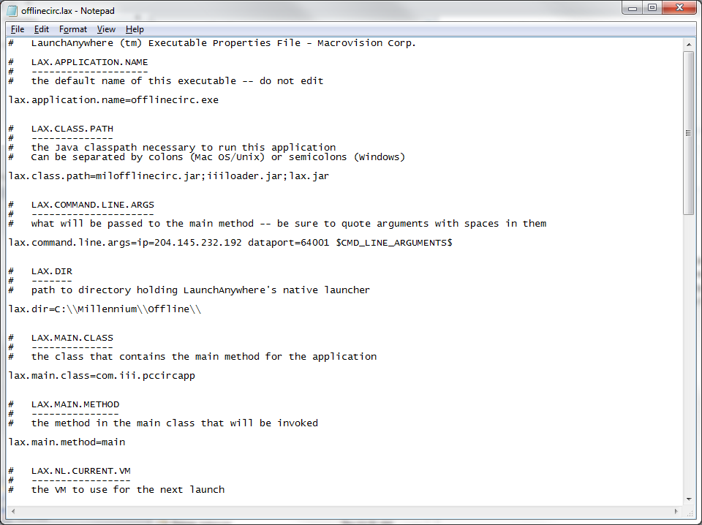

Click File, then Save.

Exit the Notepad program by clicking File, then Exit.

Using Offline Circulation

Setting your preferences

The program is now installed and the parameters changed to work in WRLSWEB. You now have to change the settings in the offline circulation program so it will allow you to check out, download your checkouts into Sierra, and keep statistics.

On your desktop, double click on the icon labeled “Millennium Offline Circulation” to load the program.

First click on View, then Preferences.

On the Statistics Group line replace the ??? with the group for your library. (Deb or Charles can provide that number).

Click in the box by “Check barcode validity” to remove the checkmark.

Click Apply to save the changes, then Quit. These preferences will be saved even after you exit the Offline Circulation program and will still be set when you load it again.

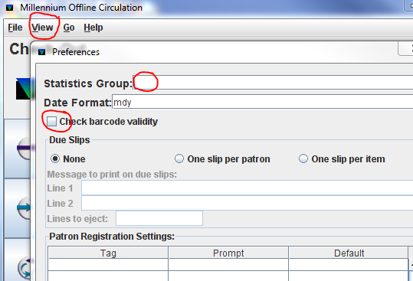

Checking out

You should be at the Check-Out screen. If not, click on the icon in the left column with the larger right facing arrow.

There will be a ‘b’ in the box under “Key or Scan Patron ID Barcode:” Be sure your cursor is to the right of this ‘b’ then scan the first patron’s barcode.

You will get a box labeled “Enter due date:” Enter the correct due date for that day and item type, using the following format: MM-DD-YYYY. (For items due April 14, 2014 you would type: 04-14-2014). When the date is set, hit Enter.

The next box is “Hourly? (Y/N):” This doesn’t apply to us, so type ‘N’ and hit Enter.

You are now ready to start scanning item barcodes. The software will keep a running list of the patron barcode, item barcode, due date, and date and time of the checkout. The list keeps going until you close the program.

If you need to change the due date for an item:
- Click on the New Due Date button.
- You will get the “Enter due date:” box again, with the current due date entered and highlighted.
- Type in the new date, using the MM-DD-YYYY format as before, and hit Enter.
- The next box is “Hourly? (Y/N):” with the current answer (N) highlighted. Hit Enter.

Continue to check out items to the patron. The new due date will remain until you change it to something else or exit the program. Be sure to change due dates as needed.

When finished with one patron be sure to click the New Patron button right away, even if you don’t have another patron waiting. This will ensure that you don’t check out items to the wrong patron.

When ready to check out to the next patron, scan their patron barcode. You will get the box to set the due date again. Change the date if needed, otherwise just hit Enter. In the box for Hourly you can hit Enter again. Then begin scanning item barcodes again, changing due dates as needed.

Uploading Offline Circulation Files

When Sierra is available, you will be contacted by phone by someone from WRLSWEB about uploading your files (Charles or Deb or Alan). One of those people will walk you through the process of uploading the files. DO NOT UPLOAD ANY FILES BEFORE CONTACTED! We need to do the libraries one at a time in order to insure all transactions are uploaded correctly.

Once contacted you will go to File, then choose ‘Upload circulation and patron data.’

A box will display, asking “Is the server ready to receive data? If so, choose YES to upload data.” Once the staff at WRLSWEB confirms the server is ready, click Yes.

When your data has been received at the server the staff member helping you will process the file(s) you send. Once that’s completed, you can clear the file. DON’T CLEAR THE FILE UNTIL YOU GET THE OK! If the data doesn’t process successfully it can be done again if you don’t clear.
When told that your data processed successfully, then it is important to clear the file. If you don’t clear at this point the data will remain and the next time you use Offline Circ it will check those items out again.

When you get the go ahead to clear the data, click on File and then on ‘Erase circulation transactions.’ A box will appear saying “Are you sure you want to erase circulation transactions?” Click Yes.

This completes the offline circ procedure and readies the program for the next time it’s needed.

